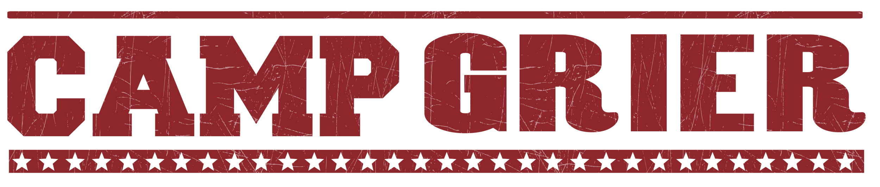

STAFF PACKING LIST
Please do NOT bring:
Candy or Gum
Food
Weapons of any kind
Non-prescription drugs
- Daypack (bookbag)
- Flashlight or headlamp
- BUG SPRAY!!!
- Sunscreen
- 2 Water Bottles
- Bedding
  - Sleeping Bag
  - Blanket/Sheets for single bed
  - Pillow
- Laundry bag
- Laundry detergent
- Toiletries
  - 2-3 Towels
  - Washcloth
  - Toothbrush, toothpaste, etc.
  - Soap, shampoo, etc .
  - Deodorant
- Pajamas
- Outdoor clothes that are comfortable and can get dirty!
  - Quick dry shirts, t-shirts, tanks
  - Shorts
  - Pants
  - Appropriate Swimwear
  - Sweater and/or warm jacket (it can get chilly in the evenings)
  - Rain gear (Rain jacket or poncho)
  - Baseball hat, possibly a winter hat
  - Sunglasses
- Footwear
  - Tennis shoes
  - Water shoes that can get wet (must have a backstrap)
  - Sturdy hiking shoes
  - Socks (can never have too many) including a heavy pair for hiking
  - Shower shoes (Flip flops are not allowed outside of the cabin)
- Journal
- Pencil or Pen
- Specialty camps: we provide bikes and helmets (both for MTB and equestrian). You are welcome to bring your own if you prefer.

Optional but helpful for staff:
- Waterproof watch
- Camera
- Bluetooth speaker to play music
- Deck of cards/card games
- Hammock and Rain Fly!! Hammocks are NO LONGER ALLOWED UNDER COOKOUT SHELTERS. This is a huge safety risk. Hammock trees will be designated outside each cabin.
- Multitool for cookouts
- Costumes/accessories for rustic dance themes (we can also do thrifting trips over the weekends)
- Laptop - not necessary, but the IC is a safe place to store it if you do choose to bring it
- Camp provides backpacking packs but you are welcome to bring your own if you prefer

